Lab4 Solutions

# Problem 1

The following sequence diagram is incomplete. Re-draw the diagram so that it follows UML syntax rules.

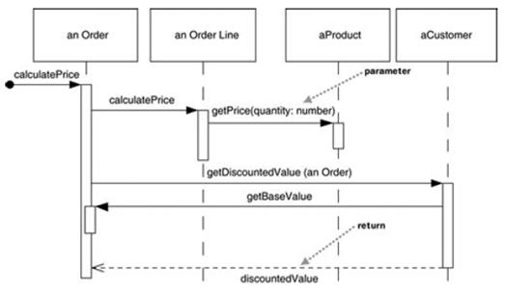

In your diagram, do the following:

* •  Include message numbering
* •  Use proper UML syntax for the objects displayed at the top.
* •  Indicate looping wherever it occurs with Iteration markers

**Solution:**

# Problem 2

Create a sequence diagram based on the flow that occurs when an actor invokes the checkoutBook() method on CheckoutForm

//FROM CLASS CheckoutForm

public void checkoutBook() {

theCheckoutController.checkoutBook(m_book, m_member); displayCheckoutInfo();  
clearCheckoutFields();

}

//FROM CLASS CheckoutController  
public void checkoutBook(Book book, LibraryMember member) {

CheckoutRecord aCheckoutRecord = new CheckoutRecord(); aCheckoutRecord.setDueDate(member.getCheckoutPeriod()); aCheckoutRecord.addBook( book );  
member.addCheckoutRecord( aCheckoutRecord ); theILibraryDBSubsystem.addCheckoutRecord(member.getMemberID(), aCheckoutRecord)

}

**Solution:**

# Problem 3: Payroll Calculation

Problem on Polymorphism

**Solution:**

Solved in eclipse file with name ‘***MPP-Lab4’***under the package **‘prob4C’**

# Problem 4

Create a sequence diagram for the problem described in Lab 4, Part C. Create a distributed control solution. As you distribute control, make sure that the object that handles a step of processing really should be responsible for that behavior, based on the purpose of the class that was determined in the class diagram.

**Solution:**

